Welcome to the new Yamj skin called Jericho.

I made this skin for myself as I needed a skin that showed the fanart off in the index pages and also as my Tv is about 10 feet away I needed the plot text to be larger then some of the other skins.

The skin uses distorted fanart images in the index pages much like the BT vision tv commercial.
You will need imagemagick installed to create those images.

Please download and install ImageMagick-6.5.7-4-Q16-windows-dll.exe first.

The skin is just based on Excals redefined skin and I have just modified some code and added a few image’s and some xsl scripts.

In the Jericho skin folder are a few more xsl scripts.

Jericho-Details-Movie.xsl
Jericho-Index.xsl
Jericho-templates.xsl

And within the html folder is the Jericho image’s folder that the skin uses, you don’t need to modify or open the xsl files.

Ok let’s get started.

Change the line below in the moviejukebox properties file to point to the Jericho skin
mjb.skin.dir=./skins/Jericho

Run Yamj

When yamj has done its work your index pages will look something like this.

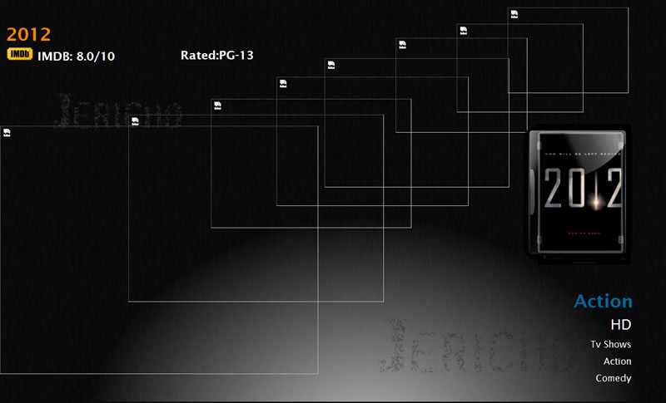

You will need to run the fanart-border {run this first}.bat file to generate the fanart.png images.
Then your index should look like this below.

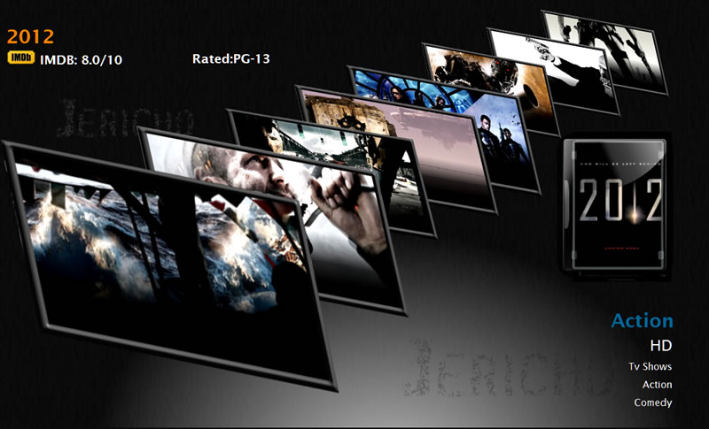

Next you will need to run either the
fanart-gradient_for_720p.bat
or
fanart-gradient_for_1080p.bat to add a gradient to your fanart.jpg images, this will add a dark gradient at the bottom so the video/audio spec images show more clearly.

Note
If you add more movies at a later stage you will need to process them in a separate folder as the bat file will just process anything with a .fanart in its filename.

If everything has done its job correctly your details pages should look similar to this below.
Depending on the video/audio properties of the movie the video/audio codec info will change accordingly.

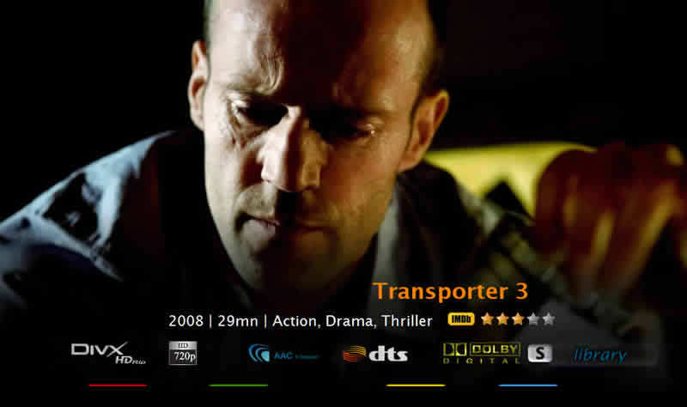

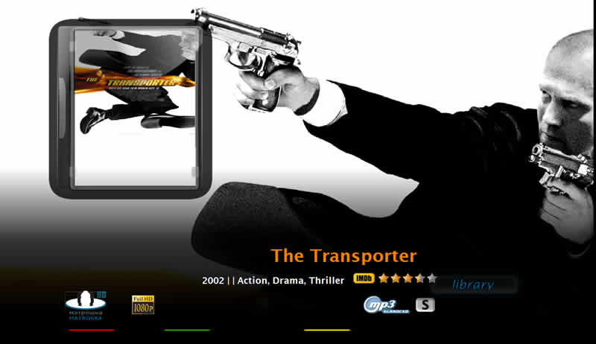

If you have sets in your jukebox you will need to create a fanart for the set’s first before running the .bat scripts earlier.

Example below
Set_Austin Powers Shagadelic Box Set_1.html

Grab an image off the moviedb.org website http://www.themoviedb.org/movie
And rename it the same name as the set filename below (note the image size 1280x720 or 1920x1080).
Set_Austin Powers Shagadelic Box Set_1.fanart.jpg
and then use the .bat convert tool to convert to:
Set_Austin Powers Shagadelic Box Set_1.fanart.png

Create the set fanart jpg’s before running the fanart-border {run this first}.bat and
fanart-gradient_for_720p.bat
or
fanart-gradient_for_1080p.bat
It would be advisable to keep all the fanart images the same resolution.

I have included a working-folder with all the .bat and border and gradient images in,
if you only need to process 1 or a few movie fanart images, drag or copy them to this folder.

Bare in mind what resolution your fanart images are either 1280x720 or 1920x1080 and use the correct .bat script for that image resolution otherwise you will end up with the image below.
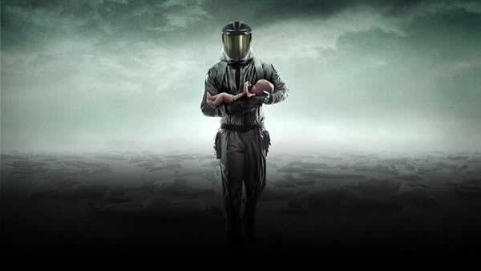

and not this….

You may also edit the .bat script to just use the file name you want to process.
There’s a line that starts with:
FOR %%1 in (*.fanart.jpg) you can change the *.fanart.jpg to the filename you want to process.

NOTE
Try and keep your fanart at 1280x720 as the pch doesn’t show the entire image and the black fade-in will be cut off.
Also if the moviechange is slow it might be because your jukebox is coming over a wireless connection, its advisable to keep to a wired connection.

Enjoy!

