Here is a quick guide of how to make the HQ Box Covers addon work...
Before we start, this guide assumes you know you’re way around Yet Another Movie Jukebox, or what is more commonly called YAMJ. This addon will (fingers crossed!) convert your movie and tv show posters into boxed cover art, both thumbnails and posters. If you have problems with YAMJ then search on www.networkedmediatank.com for help.
For this to work you need a fully working movie jukebox, if you can’t get this working then don’t start playing with Box Covers.

Video Sources
For the addon to correctly recognise what box cover to add, you need the video sources to be correct for all of your Movies and TV Shows. A video source is basically what format the movie started life as, whether it be from TV, or from a Blu Ray or HDDVD disc. For example, if you want your Dark Knight movie to have a Blu-Ray cover, then the movie filename needs to be for example The Dark Knight [1080p-BluRay].mkv for example. As long as BLURAY, BDRIP, BLURAYRIP, or BLU-RAY are in the movie name somewhere then the source will be recognised.
Below is a list of all video sources recognised by YAMJ and what filename tags to use:
http://code.google.com/p/moviejukebox/wiki/VideoSources
The Box Covers addon currently recognises the following video sources:
BluRay, Cam, D-Theater, DVD, DVD5, DVD9, DVDRip, DVDSCR, HDDVD, HDTV, PDTV, R5, SDTV & TS
The above will all be assigned their relevant Box Cover, if your source is UNKNOWN then a box will still be used however it will be a plain black box cover.
Installing The Addon
As I can’t account for all different methods of using YAMJ, I will explain how I use the software.
At present my movies are run from my computer, a windows xp pc, and stored on the internal hard drives. YAMJ is on one of these drives and shared to my networked media tank via SMB. So my YAMJ and my Box Covers addon are all run from and stored on my PC.
Some users will store and run YAMJ on their NMT’s, Box Covers should still work however may be slowed down significantly by running across a network. If you store YAMJ on your NMT’s internal drive, it may save time to copy the entire folder to your computer once you have run YAMJ, run the box covers addon, then copy the folder back to the NMT...
This addon can be quite time consuming to run, it is dependant on your computer speed and the number of movies in your jukebox. I have approx 400 movies and it takes my ageing PC, an Athlon X2 4200+ with 2Gb ram, about 30 to 40 minutes to run with reflections turned on.
Step by Step..
Firstly download imagemagick from here (choose the top one - Win32 dynamic at 16 bits-per-pixel)...
http://www.imagemagick.org/script/binary-releases.php#windows
If the link stops working then go to the imagemagick.org website, from the left menu bar choose windows under the binary releases section. When you install the program you must have "Add application directory to your system path" ticked, otherwise this addon won't work.

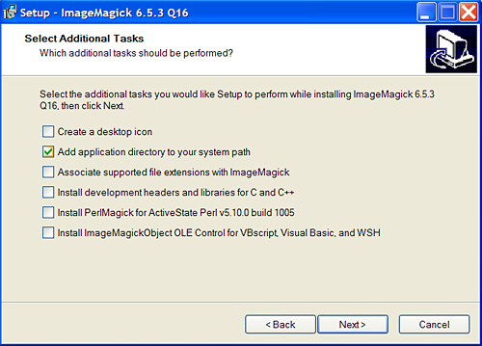
What this means is that in a dos prompt within windows you can just type in convert (one of the imagemagick commands) from any location and it will run imagemagick. This is only a command line program so don't expect to see anything other than a list of options... See below..

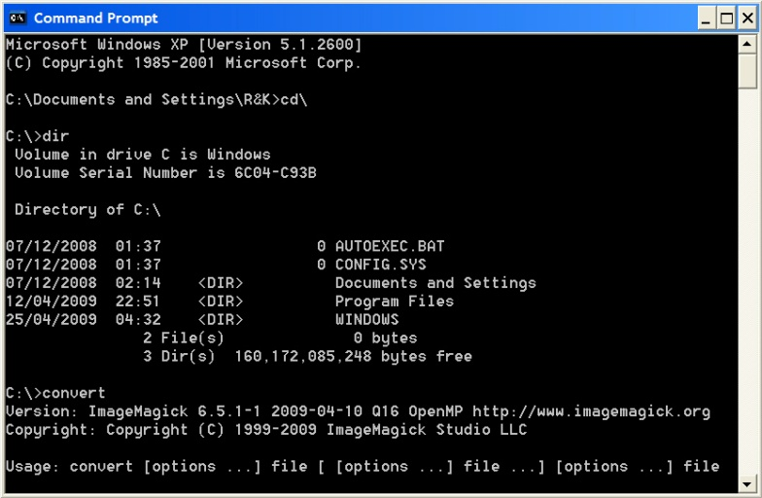

Next you need to have YAMJ already run and your jukebox working as normal. You should have a folder you told YAMJ to generate into, this will have inside it another folder with all the images and xml and html files in, also there should be an index.htm file.
Place the entire BoxMeHQ folder in the same place as the index.htm file. So you should see the index.htm, the BoxMeHQ folder and the folder probably called Jukebox with all the images etc. inside it.
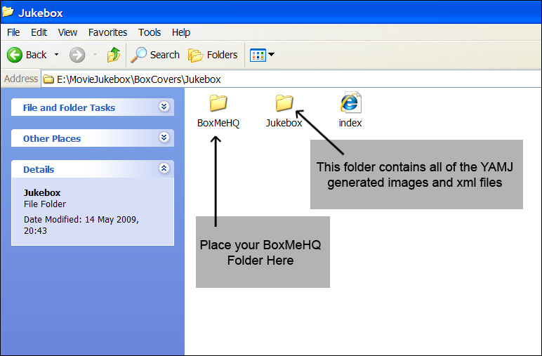
To run the addon open the BoxMeHQ folder and double click on DoTheMagic.bat, the below options screen should appear.
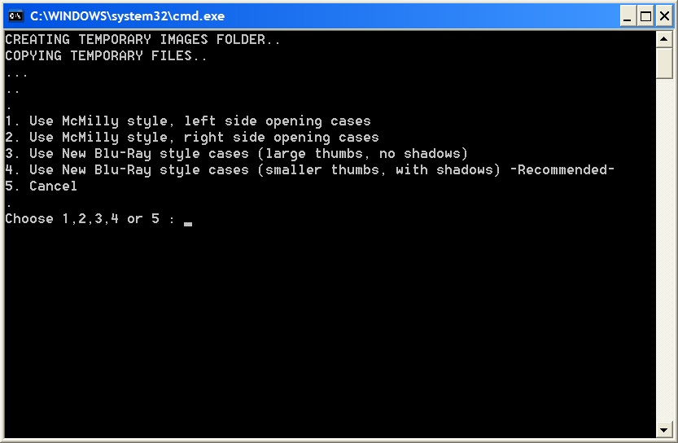

This is a new addition if you’ve been using the old BoxMe addons. Basically this allows you to choose the style of Box Covers you want. There are four options, as shown. Example images shown later in this readme.
When you have chosen the first option, you will see another menu as below.
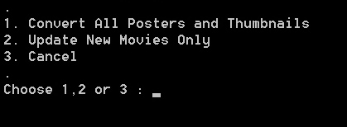
Choose option 1 if this is the first time you’ve run the addon, this will then convert all of your movie posters into box covers and thumbnails. Can take some time if your collection is large.
See Error messages section if you are unsure of some messages you might see.
Important:- To make option 2 work, you need to go into your YAMJ folder where all the images, posters, thumbnails etc are and check the height of one of the thumbnails, this needs to be inputted into the DoTheMagic.bat so it can search for new movies only.
The height you input needs to be the thumbnail height (file ends in _small) **BEFORE** you have run BoxMe, i.e. the original generated thumbnail height from just running YAMJ on it's own. See image below. You can see the height of my thumbnail is shown as 273 pixels.
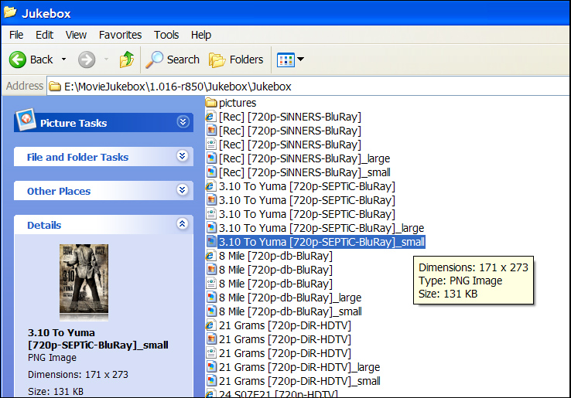
To edit the .bat files all you have to do is right click on the file and then click edit. This will bring the file up in notepad where you can make changes, save it before closing otherwise your changes will not be saved. This thumbnail size is the only information required in DoTheMagic.bat, you shouldn’t have to change anything else in this file.
There are more options and some instructions in the BoxMe.bat files, there are BoxMe.bat files in each of the Resource directories inside the BoxMeHQ folder. You will need to set your options in each of the resource directories as they are all separate and have different values. You cannot change one BoxMe.bat and copy it to the other folders to save time as the end result will be incorrectly generated images.
Standard Options
As standard if you change nothing, the box covers will be generated with the following options:
SET RESIZETHUMB=NO : SET LARGEPOSTER=BOXED : SET HDPOSTERTAG=NO : SET HDTHUMBTAG=NO
SET STACKSETS=NO : SET PLAINSETCASE=YES : SET POSTERPERSPECTIVE=YES : SET POSTERREFLECT=YES
SET THUMBPERSPECTIVE=NO : SET THUMBREFLECT=YES : SET PERSPECTIVEPERCENT=3
These are all accessed in the BoxMe.bat file in each resource directory, at the top of the file.
This will generate boxed covers for both thumbnails and large posters, you can leave the large posters alone and have them displayed as they normally would if you wish (change the relevant option to SET LARGEPOSTER=NOTBOXED). The thumbnails will be set at the maximum size possible in YAMJ, and they won’t have the small corner tags to indicate if they are 720p or 1080p files, turn this option on if you want to. If you have sets of movies or tv series, these will be generated with just a plain grey case unless you choose otherwise.
To change the above options is simple, just edit the .bat file and follow the instructions.
Addition to the above options – You can have SET HDTHUMBTAG=UNKNOWN this will only give your thumbnails corner 720p or 1080p logos if the source is unknown. Another addition is now PERSPECTIVE which is as standard turned off for the thumbnail as it doesn’t look right to me, edit the BoxMe.bat files to switch this option on or off, you can choose to have perspective on posters, thumbnails or both, and the amount of distortion is changeable. WARNING – USING PERSPECTIVE WILL NOTICEABLY BLUR YOUR IMAGES
NEW ADDITION IS REFLECTIONS – THIS WILL SLOW DOWN THE RUN TIME SO BE PATIENT
Stacking set thumbnails
To use the stacked boxes, set the option to SET STACKSETS=YES, and choose either the plain black box cover (option SET PLAINSETCASE=YES) or the alternative which is a black box with BOX SET logo at the top (option SET PLAINSETCASE=NO).
In order for the stacking to work, you must have set images in your Jukebox directory. For example for a set of Terminator movies, you must have correctly set up the sets in YAMJ already, then in the images directory there should be a SET_Terminator Collection_1.jpg file, if there isn’t then stacking won’t work correctly.
For TV series with multiple seasons, you might have to copy an image manually into your Jukebox directory with the correct set name if there isn’t one already there. A correct image name for example might be Set_Prison Break_1.jpg, there may be an image in the folder already this will be the same as the first season’s cover unless you manually make your own.

Error messages
Unfortunately due to the nature of my programming knowledge there might be error messages even when everything is fine. Don’t worry about them unless your images are not being generated correctly.
If your images have not appeared as they should do please double check you have followed the instructions properly, I will regularly check networkedmediatank.com for questions.
Best Practice
To avoid having to constantly re-run YAMJ, I find it best to run YAMJ once, then copy the result to another folder to run BoxMeHQ. This avoids any inadvertant errors and you will have a backup of your YAMJ should you run into trouble.
You can then share to different jukeboxes to your NMT if you wish, one normal and one with the boxed covers.
Good luck.

See Final Pages for example images..
*********************************************************************************
Please note that the code contained in BoxMeHQ is not all my work, the original code has been coded and conceived by warrick from networkedmediatank.com with images made by mcmilly
I have altered his code quite significantly to my own liking and also worded the code and written these instructions to make it easier to understand. I do not and have not ever claimed his work as my own. Other changes I have made include re-Photoshopping the Box Covers and improving them with larger logos. More recently I have created the new BD-style covers from scratch in Photoshop.
Please see warrick's original thread for the basis of this code and more instructions. There are several versions of BoxMe to download from there with more options.
warrick's original Box Covers "BoxMe" thread :-
http://www.networkedmediatank.com/showthread.php?tid=19951

Kendo.
**********************************************************************************

Example set thumbnails using mcmilly cases:
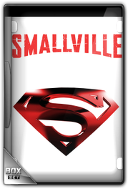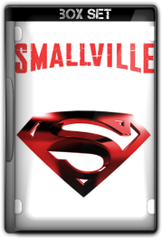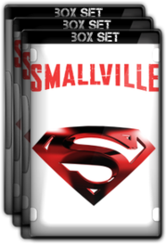
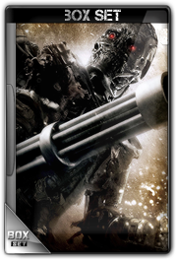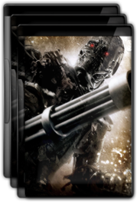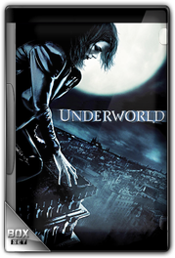
Examples of the new BD style cases, left (option 4) and right the old mcmilly style cases (option 2).


